
Citizenship, Economics and Society
(Secondary 1-3)
Support Resources
Secondary 3

Module 3.2
Overview of Our Country’s Economy and World Trade
Part 3:
World Trade
Personal, Social and Humanities Education Section
Curriculum Development Institute
Education Bureau
Introduction

- The “Citizenship, Economics and Society (Secondary1-3) Support Resources” covers the essential learning contents of Strands 1, 5 and 6 in the Personal, Social and Humanities Education Key Learning Area. It is designed to support the implementation of the Citizenship, Economics and Society curriculum.
- The support resources provide diversified learning activities to help students acquire knowledge and understand concepts, develop skills and nurture proper values and attitudes. In addition, they offer teaching guidelines and suggestions on learning and teaching activities for teachers’ reference. Further, they provide reading materials to enhance students’ interest in reading.
- “Module 3.2: Overview of Our Country’s Economy and World Trade Part 3: World Trade” for Secondary 3 was developed by the Personal, Social and Humanities Education Section, Curriculum Development Institute of the Education Bureau. Part of the contents are based on the learning and teaching materials developed by the Business School of the Chinese University of Hong Kong and Hong Kong Effective Teaching Association, commissioned by our section in 2019 and 2014 respectively.

Module 3.2 Overview of Our Country’s Economy and World Trade
Part 3: World Trade
Contents

 | Page
Introduction | 4
Teaching Design
Lesson 1 and Lesson 2: Basic knowledge of trade | 5
Lesson 3 and Lesson 4: Present situations, opportunities and challenges of external trade of the Mainland and Hong Kong | 7
Lesson 5 and Lesson 6: Common trade protection policies, reasons for implementing these policies and ways to deal with them | 9
Lesson 7: Functions of the World Trade Organization and the challenges of our country’s external trade - China-US trade war | 11
Learning and Teaching Activities
Lead-in Activity Worksheet | 12
Worksheet 1: Overview of the external trade of our country | 17
Worksheet 2: Overview of the external trade of Hong Kong | 19
Worksheet 3: Opportunities and challenges of external trade of the Mainland and Hong Kong | 34
Worksheet 4: Common trade protection policies | 38
Worksheet 5: The World Trade Organization | 40
Worksheet 6: Challenges of our country’s external trade – China-US trade war | 42
References | 44
Introduction
This resource aims to enable students to understand that economic activities generated by external trade are one of the important driving forces for the economic prosperity of our country. They will also understand the impacts brought by world trade on the economic development of the Mainland and Hong Kong. Firstly, students will learn the basic knowledge of trade, the benefits it brings to the economy as a whole and its potential impacts on the interests of certain people (e.g. import-competing industries), They will also understand the present situation of external trade in the Mainland and Hong Kong, and the opportunities and challenges they are facing. Moreover, students will learn about some common trade protection policies, reasons for implementing these policies, and the ways to deal with trade protection policies, including the functions of the World Trade Organization. Lastly, they will have a preliminary understanding of the potential impacts on the economy of our country brought about by trade conflicts and the importance of safeguarding economic security to protecting economic development.

Objectives
- To understand the impacts of world trade on the economic development of the Mainland and Hong Kong
- To develop and nurture relevant generic skills, values and attitudes

Learning Points
- Acquire the basic knowledge of trade
- Understand the impacts of world trade on the economic development of the Mainland and Hong Kong
- Recognise the common trade protection policies and the reasons for implementing these policies
- Understand the ways to deal with trade protection policies and the functions of the World Trade Organization
- Develop a preliminary understanding of the potential impacts of trade conflicts on the economy of our country and the importance of safeguarding economic security to protecting economic development

Suggested Number of Lessons
- 7 lessons (40 minutes each)
Teaching Design
Topic: | World Trade
Duration: | 7 lessons
Learning Objectives: | - To master the basic knowledge of trade  - To understand the impacts of world trade on the economic development of the Mainland and Hong Kong  - To recognise the common trade protection policies and the reasons for implementing these policies  - To understand the ways to deal with trade protection policies and the functions of the World Trade Organization  - To develop a preliminary understanding of the possible impacts of trade conflicts on the economy of our country and the importance of safeguarding economic security to protecting economic development
Lesson 1 and Lesson 2 (Basic knowledge of trade)
 |  | Suggested lesson time
Enquiry process: | - Set:  - The teacher introduces the content of these seven lessons and then asks the students to complete Questions 1 and 2 of “Lead-in Activity Worksheet” by themselves and then discuss Question 3 with the neighboring classmate, so that students can understand that consumption activities are very common in our daily lives. | 15 minutes
Enquiry process: | - Interactive teaching：  - The teacher uses “Knowledge Content: What is trade?” to explain some basic concepts of trade such as visible trade, invisible trade, import and export, etc. Afterwards, the teacher asks students to think about and discuss the three benefits to the overall economy and harms to some people’s interests that trade brings about through answering the questions.  - Through the “Supplementary Information”, the teacher explains how to calculate the trade balance of goods, which serves as the basic knowledge for the subsequent learning content. | 60 minutes
Enquiry process: | - Conclusion:  - The teacher concludes that trade is an important economic activity between places, which brings benefits to the economy but may also cause harm to some people. | 5 minutes
Learning and Teaching Resources: | Lead-in Activity Worksheet

Lesson 3 and Lesson 4 (Present situations, opportunities and challenges of external trade of the Mainland and Hong Kong)
 |  | Suggested lesson time
Enquiry process: | - Set:  - The teacher reviews with students the basic concepts of trade learned in the previous lesson and point out that different statistical data and charts will be used in this lesson to understand the trade situation of the Mainland and Hong Kong. | 5 minutes
Enquiry process: | - Interactive teaching:  - The teacher distributes “Worksheet 1: Overview of the external trade of our country”, discusses with the students the trend of our country’s external trade since reform and opening up, and asks students to complete Questions 1-3.  - After distributing “Worksheet 2: Overview of Hong Kong’s external trade”, the teacher review with students the “Supplementary Information: Formula for calculating the merchandise trade balance” with the students” covered in the last part of the first lesson and asks students to answer Questions 1-2a. After completing the questions, students will share their answers with the whole class to make sure they know how to calculate the trade balance.  (Remark: The teacher can discuss the challenge question with students according to their interests, abilities and prior knowledge, let them know the factors that affect Hong Kong’s trade situation, and let students browse the website of the Trade and Industry Department and answer “Online Learning” Questions 1-2 to let them know Hong Kong’s position in the world merchandise trade as well as its major merchandise trading partners.)  - Next, through explaining Analysis 2 in “Supplementary Information: Formula for calculating invisible trade balance,” and the questions, the teacher points out that, in addition to merchandise trade, trade in services is also an important part of Hong Kong’s economic development. Then the teacher asks students to complete Questions 4-5 and have them share their answers and opinions. This part will help students understand the trend and current situation of trade in services in Hong Kong in recent years.  (Remark: The teacher can discuss the challenge questions 6-7 with students according to their interests, abilities and prior knowledge.)  - The teacher uses the questions in Analysis 3 to let students to express their opinions and discuss related contents with them, and finally summarises the learning from this part to ensure that students grasp the importance of external trade to Hong Kong.  - After students have understood the importance of external trade to Hong Kong, the teacher uses “Know More” to let students know how the Basic Law maintains Hong Kong’s free trade system. The teacher first explains Article 115 of the Basic Law to students and helps them grasp important concepts such as “free port” and “free trade” through the fill-in-the-blank exercise.  - The teacher then uses the “Let’s do it” exercise to help students think and analyse the circumstances under which the government will impose restrictions on the import and export of goods and how free trade will benefit different industries. | 70 minutes
 | - Summary  - The teacher states the importance of external trade to Hong Kong and points out that both the Mainland and Hong Kong's external trade are facing opportunities and challenges. | 5 minutes
Learning and Teaching Resources: | Worksheet 1 and Worksheet 2

Lesson 5 and Lesson 6 (Common trade protection policies, reasons for implementing these policies and ways to deal with them)
 |  | Suggested Lesson Time
Enquiry Process: | - Set︰  - The teacher asks students the following question: “In the previous lesson, we discussed the trade situation in the Mainland and Hong Kong. Do you remember the current situation of the trade between the Mainland and Hong Kong? | 5 minutes
Enquiry Process: | - Interactive Teaching:  - The teacher distributes “Worksheet 3: Opportunities and challenges of external trade of the Mainland and Hong Kong”. The teacher first discusses with students the advantages of Hong Kong’s external trade through the information in the first part and points out that the “14th Five-Year Plan” mentions that our country will support the promotion of the status of Hong Kong as an international trade center and give Hong Kong more opportunities for the development of external trade.  - The teacher then analyses the chart in Source 1 of “Part 2: Challenges facing Hong Kong’s external trade” with students and asks students to work in pairs to study the content of Source 2 and complete the table. After completing the task, students will share their answers and opinions to help them understand the challenges facing Hong Kong’s external trade.  (Remark: According to students’ abilities, the teacher can ask students to work in groups to discuss the current situation of Hong Kong’s trade and production where Hong Kong enjoys advantages, and then points out the importance of trade to Hong Kong.)  - The teacher discusses Source 3 and Source 4 with students and asks them to answer related questions so that they can understand the opportunities and challenges facing our country’s external trade and what strategies our country uses to promote external trade.  - The teacher distributes “Worksheet 4: Common trade protection policies” and asks the students to work in pairs to complete the form, and checks the answers with the whole class. Following the above exercise, the teacher explains trade protection policies and their impact on different stakeholders. | 75 minutes
Learning and teaching resources: | Worksheet 3 and Worksheet 4

Lesson 7 (Functions of the World Trade Organization and the challenges of our country’s external trade - China-US trade war)
 |  | Suggested Lesson time
Enquiry Process: | - Set  - The teacher reviews the contents that trade may bring harms to certain stakeholders and points out that as a result, many countries have implemented trade protection policies. | 5 minutes
Enquiry Process: | - Interactive teaching:  - The teacher distributes “Worksheet 5: The World Trade Organization”. First, students are work in pairs to complete Questions 1-2 and then the class check the answers together. This part helps students understand the basic functions of the WTO and the positive impact of our country’s entry into the WTO on the economy.  - The teacher distributes “Worksheet 6: Challenges of our country’s external trade - China-US Trade War”. Firstly, students work in pairs to complete Questions 1-2 and then share their answers. Then the teacher points out that trade conflicts may pose a threat to national economic security, and the importance of safeguarding economic security to protecting economic development. | - minutes
Enquiry Process: | - Summary:  - The teacher summarises what students have learned in this Module and let them understand the impact of world trade on the economic development of our country and Hong Kong. | 5 minutes
Learning and teaching resources: | Worksheet 5 and Worksheet 6

Module 3.2 Overview of Our Country’s Economy and World Trade
Part 3: World Trade
(Lesson 1 and Lesson 2)
Learning and Teaching Materials

Lead-in Activity Worksheet
- Lead-in activity
- In the past week, what kind of spending activities did you do? Please put down any four consumption items in the following table. (Students can answer freely)
Consumption items | Sellers | Place of production
Bread | Bakery | Hong Kong, China
Transport | MTR Corporation | Hong Kong, China
Football shoes | Sport-wears shop | Vietnam
Japanese cartoon movie | Cinema | Japan
(Note: Students may not know where the consumption items are produced, and some items are produced in more than one place. Students can simply fill in what they know.)
In the answers provided in the table above,
    - Circle or box the consumption item(s) that belong(s) to services;
    - Add a “” next to the item not produced in Hong Kong.

- Discuss with your neighboring classmate on why you cannot be self-sufficient in the above items, but need to do the above spending activities?
Not having the resources (including raw materials, skills, knowledge and time)
to produce certain items by yourself. So it is necessary to use money to obtain
the products / services in the market.



What is trade?
Trade refers to the activity of exchanging goods or services in the market, and the transaction between buyers and sellers. From the activity above, we can see that trade activities often happen in daily life.

For trade in modern society, buyers generally pay money to the sellers in exchange for goods or services. Buyers and sellers can buy and sell on individual, organisational or regional basis. With the development of technology, trade between regions are facilitated by tools such as global transportation and the Internet, so that trade can operate in a global and cross-regional mode.

Local trade refers to trade carried out only within a territory, and world trade refers to trade between different countries or regions.
Trade can be divided into two categories: visible trade (also known as merchandise trade) and invisible trade (also known as service trade).
- Visible trade refers to domestic exports, imports and re-exports of goods
  - Domestic exports of goods are goods produced by a country or a place and are sent to other places.
  - Imports of goods are goods that a country or a place buys from other places for local consumption.
  - Re-exports of goods are goods that are first imported from a place and then sent to another place.
- Invisible trade refers to exports of services and import of services
  - Exports of services is the sale of services to the rest of the world.
  - Imports of services is the purchase of services from the rest of the world.
  - Service imports and exports are classified based on different service categories, including transportation, travel, insurance services, financial services, business services, other trade-related services, and other services.

(i) Benefits of trade
Through trade, production units can specialise their production where they enjoy advantages, and then conduct free trade in exchange for the goods or services they need. Regional production has become specialised, which will focus on the production of certain goods identified as enjoying advantages and make good use of resources and economies of scale in order to increase the total amount of outputs and promote economic efficiency.
Simply put, trade brings the following three benefits to the economy as a whole. Give each benefit a title based on its description.
Benefit 1: | Raise the productivity
Through trade, the region does not need to produce all of the goods it needs, but only those identified as enjoying advantages, making regional production more specialised and raising the productivity。
Benefit 2: | Provide diversified choices for consumers
Trade can also allow regions to obtain a wider range of goods than they could produce on their own, providing consumers with more choices.
Benefit 3： | Boost economic growth and development
In the trade process, regions compete with each other in the market, which helps improve product quality or production technology. By attracting buyers from around the world to buy locally produced goods or to invest locally, trade helps boost economic growth and development.

(ii) Harms brought about by trade
Fill in the blanks: From the phrases provided below, find the correct phrases to fill in the brackets.
jobs advantages wealth disparity production cost
trade agreement local culture unemployment

In the process of trade, regions concentrate on the production of goods or services with ( advantages ). In the global competitive environment, labour and the overall economy are faced with many challenges brought about by trade. For example:

- Labour involved in production of goods without advantages will face unemployment risks: In the face of global competition, when conducting world trade, regions will concentrate on producing items with advantages, so that ( jobs ) will be concentrated in production of items with advantages, and jobs involved in production of items without advantages will be lost. If those workers who are engaged in production of items without advantages are unable to transit to production of items with advantages, there will be risks of ( unemployment ).

- Less competitive industries would be replaced. Some less-competitive industries have higher ( production costs ) to produce similar goods than other regions. As a result, many multinational corporations relocate their investment to lower-cost regions, rendering less-competitive industries inactive locally and being replaced by other regions, and affecting the development of the industry locally. Many of these less competitive industries are industries on ( local culture ) that cannot be mass-produced, thereby affecting the inheritance of traditions.
Extended Learning: The teacher may take into consideration students’
interests, abilities and prior knowledge and decide to discuss with them how a country or region can respond to the challenges brought about by the opening up of trade.

Supplementary Information: Formula for calculating the merchandise trade balance
The merchandise trade balance is the difference between the total value of exports and total value of imports of goods of a country (region) over a period of time; and the total value of exports goods includes the total value of domestic exports of goods and total value of re-exports of goods.
Merchandise trade balance (or visible trade balance)
Total value of domestic exports of goods
Total value of re-exports of goods
Total value of imports of goods
=
+
-

When the merchandise trade balance is in deficit, it means that the region’s total value of imports of goods is greater than the total value of exports of goods, that is, there is a merchandise trade deficit. Conversely, when the merchandise trade balance is in surplus, it means that the region’s total value of exports of goods are greater than the total value of imports of goods, that is, there is a merchandise trade surplus.

Module 3.2 Overview of Our Country’s Economy and World Trade
Part 3: World Trade
(Lesson 3 and Lesson 4)
Learning and Teaching Materials

Worksheet 1: Overview of the external trade of our country
Source 1: Total imports and exports of goods of the Chinese Mainland
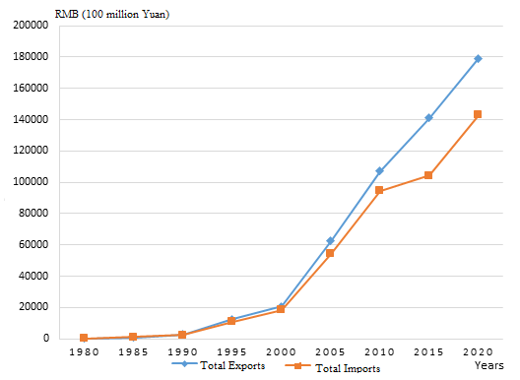
Source：Source: National Bureau of Statistics (2021)., 11-2 International Trade in Goods, China Statistical Yearbook 2021.

1. According to Source 1, what is the trend of China’s total imports and exports of goods?
China’s total imports and exports of goods were at a low level before 1990.
They have been on an upward trend since 1990, and have begun to increase at a
faster rate since 2000.
The total exports of goods rose from about 2000 billion yuan in 2000 to 18
trillion yuan in 2020, an increase of more than nine-fold, while total imports of
goods rose nearly seven-fold over the same period.

- Did China experience a merchandise trade deficit or a merchandise trade surplus in 2020?
In 2020, China had a merchandise trade surplus because its value of exports of
goods was higher than its value of imports of goods.

Source 2: International trade in goods by country (region) of origin / destination (2020) (RMB 100 million)
 | Total | Exports | Imports
Asia | 165,184.4 | 85,152.6 | 80,031.7
Africa | 13,011.4 | 7,910.3 | 5,101.1
Europe | 62,800.1 | 37,109.1 | 25,771.0
Latin America | 22,168.5 | 10,431.4 | 11,737.1
North America | 45,082.4 | 34,192.2 | 10,890.2
Oceanic | 13,745.7 | 4,483.0 | 9,262.7
Source：National Bureau of Statistics (2021), 11-5, International Trade in Goods by Country (Region) of Origin/ Destination (2020), China Statistical Yearbook 2021

- According to Source 2, in 2020, with which regions did China have merchandise trade surpluses? With which regions did China have merchandise trade deficits ?
Merchandise trade surplus: Asia, Africa, Europe, North America
Merchandise trade deficit: Latin America, Oceania

Worksheet 2: Overview of the external trade of Hong Kong
Hong Kong is a free trade port*, and world trade plays an important role in Hong Kong’s economic development. In 2021, the total merchandise trade of Hong Kong accounted for 3.1% of the world’s total trade value, ranked sixth among major trading countries/regions. The Mainland is Hong Kong’s most important trading partner. (*Note: “Know More” on p. 29 will briefly describe how the Basic Law protects Hong Kong’s status as a free port.)
Trade includes transactions in goods and services. Try to look at the current situation of Hong Kong’s trade from the following two aspects of trade data.
Analysis 1: What is the trend of Hong Kong’s external merchandise trade in recent years?
Source 1： Hong Kong’s external merchandise trade from 2012 to 2021
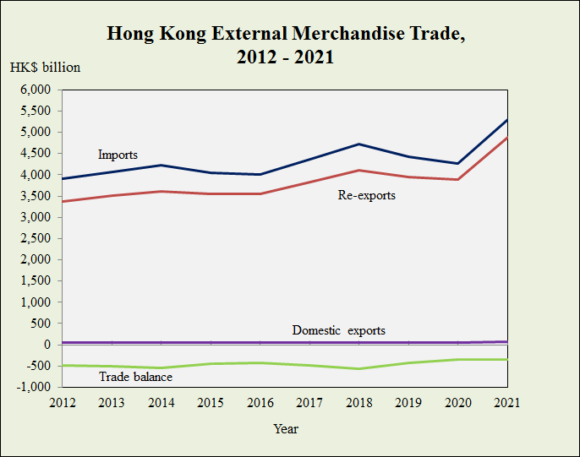
Source: Trade and Industry Department
https://www.tid.gov.hk/english/aboutus/publications/tradestat/10yrs.html
【Remark: Imports are goods which have been produced or manufactured in places outside the jurisdiction of Hong Kong and brought into Hong Kong for domestic use or for subsequent re-export as well as Hong Kong products re-imported. Domestic exports are the natural produce of Hong Kong or the products of a manufacturing process in Hong Kong, which have changed permanently the shape, nature, form or utility of the basic materials used in manufacture. Re-exports are products which have previously been imported into Hong Kong and which are re-exported without having undergone in Hong Kong a manufacturing process which has changed permanently the shape, nature, form or utility of the product.
Source: https://www.censtatd.gov.hk/en/data/stat_report/product/B1020007/att/B10200072001AN01B0200.pdf】
- According to Source 1, describe the trends of Hong Kong’s external merchandise trade (including imports, domestic exports and re-exports of goods) from 2016 to 2021.
Source 2 shows that Hong Kong’s imports and re-exports of goods showed an
upward trend from 2016 to 2018, but began to decline in 2018 and rebounded in
2020; while domestic exports of goods remained steady during this period.

- The following shows the situation of Hong Kong’s external merchandise trade from 2018 to 2021. Study the data in the table below and answer the questions below.
- According to the formula in “Supplementary Information”, calculate and fill in the values in the blanks of the table below. (Unit: in HK$ million)
Years | 2018 | 2019 | 2020 | 2021
Imported goods | 4,721,399 | (b) 4,415,440 | 4,269,752 | 5,307,792
Domestic exports of goods | 46,294 | 47,751 | (c) 47,442 | 74,531
Re-exported goods | 4,111,812 | 3,940,935 | 3,880,075 | (d) 4,886,125
Merchandise Trade Balance | (a)-563,293 | -426,754 | -342,235 | -347,136
Source:
Census and Statistics Department（2022）
https://tradeidds.censtatd.gov.hk/Index/148649f64b6447ce84636e8e1dea4063

- Based on the above table, briefly describe the merchandise trade balance of Hong Kong in recent years by choosing the suitable phrases from the table below and filling in the blanks.
imported goods deficit less than re-exports domestic exports

Hong Kong’s merchandise trade balance has consistently been ( less than ) zero, which means that Hong Kong’s merchandise trade ( deficit ) has been running annually, reflecting the income earned from ( domestic exports ) and ( re-exports ) is less than the spending on ( imported goods ).

- Challenge question: Following question 2, based on your understanding of Hong Kong’s economy, explain why Hong Kong’s merchandise trade balance and re-export trade have been like this in the past.
- In terms of imports, since Hong Kong lacks natural and productive resources,
it needs to import a large number of goods from other places to meet the
consumption needs of the people. With the continuous growth of Hong Kong’s
economy, the total value of imported goods is also rising.
- In terms of exports, due to the continuous transformation of Hong Kong’s
economy, the share of the manufacturing industry in Hong Kong’s economy
has been declining. As a result, the total value of domestic exports
has been declining.
- In terms of re-export trade, with the country’s accession to the WTO, Hong
Kong has always played an important role in the economic and trade
exchanges between the Mainland and the rest of the world. Therefore,
re-export trade has continued to increase.

Online learning:
Try browsing the website of the Trade and Industry Department and answer the following questions.
(https://www.tid.gov.hk/english/aboutus/publications/tradestat/wmttt.html
https://www.tid.gov.hk/english/trade_relations/mainland/trade.html)

- According to the data in 2021, what is the ranking of the merchandise trade (in terms of total trade value) of Hong Kong, China among the world’s major trading countries and regions? What percentage does its total trade value account for in the world’s total trade value?
Answer: the sixth place, accounting for 3.1% of world trade value.

- Based on the data in 2021, make a pie chart showing the shares of Hong Kong’s major trading partners in Hong Kong’s total trade value.
Reference answer:

Analysis 2: What is the trend and current situation of Hong Kong’s trade in services in recent years?

Source 3: Hong Kong trade in services statistics, 2010 - 2020
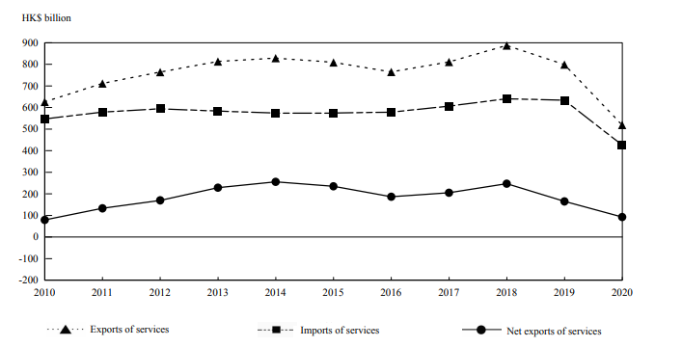
Source：Census and Statistics Department, Hong Kong Trade in Services Statistics in 2020，Page 16 https://www.censtatd.gov.hk/en/data/stat_report/product/B1020011/att/B10200112020AN20B0100.pdf

Supplementary Information: Formula for calculating the service (invisible) trade balance
Trade in services is also known as invisible trade. The invisible trade balance is the difference between the total value of exports of services and total value of imports of services of a country (region) over a period of time.
Invisible trade balance
Total value of exports of services
Total value of imports of services
=
-

When the invisible trade balance is a deficit, it means that the total value of imports of services in the region is greater than the total value of exports of services, that is, there is an invisible trade deficit. On the contrary, when the invisible trade balance is a surplus, it means that the total value of exports of services in the region is greater than the total value of imports of services, that is, there is an invisible trade surplus.

Source 3: Hong Kong’s trade in services with major trading partners in 2018

Source: Census and Statistics Department, Hong Kong Trade in Services Statistics in 2020, Page 14
https://www.censtatd.gov.hk/en/data/stat_report/product/B1020011/att/B10200112020AN20B0100.pdf

- According to Source 3, briefly describe the balance of trade in services in Hong Kong in recent years by choosing the suitable phrases from the table below and filling in the blanks.
imports of services surplus greater than re-exports exports of services

Hong Kong’s balance of trade in services has always been ( greater than ) zero, which means that Hong Kong’s trade in services has been in ( surplus ) every year, reflecting the income earned from ( exports of services ) is more than the spending on ( imports of services ).

- According to Source 3, which place is Hong Kong’s most important trading partner in services?
According to Source 3, the Mainland is Hong Kong’s most important
trading partner in services.

Source 4: Hong Kong’s service exports by service components from 2018 to 2020

Service Component | Year | HK$ million | Share (%)
Transport | 2018  2019  2020 | 258,847  246,749  185,876 | 29.2  30.9  35.8
Travel | 2018  2019  2020 | 288,974  226,559  22,176 | 32.6  28.4  4.3
Insurance and pension services | 2018  2019  2020 | 11,664  11,145  9,051 | 1.3  1.4  1.7
Financial services | 2018  2019  2020 | 174,083  169,110  168,508 | 19.6  21.2  32.5
Telecommunications, computer and information services | 2018  2019  2020 | 23,136  24,220  25,720 | 2.6  3.0  5.0
Other business services | 2018  2019  2020 | 117,258  108,401  97,109 | 13.2  13.6  18.7
Other services | 2018  2019  2020 | 12,921  12,758  10,507 | 1.5  1.5  2.0

Source:
Census and Statistics Department, Hong Kong Trade in Services Statistics in 2020，Page 14
https://www.censtatd.gov.hk/en/data/stat_report/product/B1020011/att/B10200112020AN20B0100.pdf

- Challenge question: According to Source 4, which two service components were the largest invisible trade pillars in Hong Kong in 2018 and 2020 respectively?
In 2018, “Travel” and “Transport” services were the top two invisible trade
pillars.
In 2020, “Travel” and “Financial Services” were the top two invisible trade
pillars.

- Challenge question: The following events have the greatest impact on which service components in Source 4? Try to explain whether the impact is positive or negative.
Event | Main Service Components Affected | Positive / negative impact
Implement the “CEPA”* to allow Hong Kong's professional services industry to enter the Mainland market | Business services | Positive impact:  It can assist and enhance the development of Hong Kong’s professional services industry and enhance the career prospects of professionals engaged in professional services in Hong Kong.
Implement the Guangdong-Hong Kong-Macao Greater Bay Area (GBA) plan and allow Hong Kong’s financial industry to start business in the Greater Bay Area | Financial Services | Positive impact:  It can give full play to its advantages as an international financial center under “one country, two systems”.
The outbreak of COVID-19 | Travel | Negative impact:  Reduce tourists.
Build a new runway at Shenzhen Baoan International Airport | Transport | Positive impact:  Provide an additional transport service option for Hong Kong’s logistics industry and tourists.  Negative impact:  Intensify competition between Mainland airports and Hong Kong International Airport.

* The full name of “CEPA” is “Mainland and Hong Kong Closer Economic Partnership Arrangement”

Analysis 3: How important is external trade to Hong Kong?
- Students can discuss the following challenge question in groups.
Challenge question: Based on the above analysis, try to (i) comment on the overall situation of Hong Kong’s external trade and areas in which Hong Kong has advantages; and (ii) point out the importance of external trade to Hong Kong.
(i)
- According to the figures of the invisible trade balance, Hong Kong has often
had an invisible trade balance surplus in recent years, which shows that
Hong Kong has an advantage in the provision of services over the
production of goods.
- Hong Kong is geographically located at the junction of trade routes,
thus becoming an entrepot between the Mainland and other places.
(ii)
- Many of Hong Kong’s exports are re- exports from the Chinese Mainland,
Japan and the United States, so external trade is very important to Hong
Kong.
- Hong Kong lacks natural resources and must rely on imported necessities
to meet the basic needs of local life.
- Another importance is to earn foreign exchange by exporting domestically
produced goods and services, and then purchase imported goods (including
food, consumer goods, raw materials and semi-manufactured products, etc)
and services at a lower cost (i.e. the “import price” is lower than the “self-
production cost”) to meet the needs of the huge Hong Kong population.



Appendix 1

Know More: How does the Basic Law maintain Hong Kong's free trade system?

Article 114 of the Basic Law
The Hong Kong Special Administrative Region shall maintain the status of a free port and shall not impose any tariff unless otherwise prescribed by law.

Article 115 of the Basic Law
The Hong Kong Special Administrative Region shall pursue the policy of free trade and safeguard the free movement of goods, intangible assets and capital.

Fill-in the blanks: In accordance with the above articles of the Basic Law, select the correct words from the table below and fill in the blanks. Some words can be used more than once.
tangible goods intangible assets without interference
enter and exit duty-free capital

- A free port refers to a port where all or most foreign goods can ( enter and exit duty-free ). Foreign goods can also be converted, processed, stored or sold in the port, subject to the relevant policies and laws of the country (or region) where they are located.
- Free trade means that trade takes place ( without interference ). Market buyers can decide the quantity to buy according to their own wishes, ability and price of goods (or services); sellers can decide the quantity to supply according to their own production capacity and the price of goods. In Hong Kong, where the service industry is increasingly important, trade is not limited to ( tangible goods ), it also includes ( intangible assets ) such as knowledge, management skills, culture, etc.
- There are no restrictions to the movement of legal ( tangible goods ), ( intangible assets ) and ( capital ) of different countries and regions in and out of Hong Kong, which has contributed to the development of Hong Kong a world-renowned free trade port.

Let’s Do It: Hong Kong is a free port, but does it impose tariff on and restrict the entry of goods?
Although Hong Kong is a trading port with a high degree of freedom, the government has set up trade barriers for a small number of items such as tobacco and alcohol for some reasons, as shown in the following figure:
According to the information published on the website of Hong Kong Customs (2022), the Customs has taken measures on the following items:
Duty：
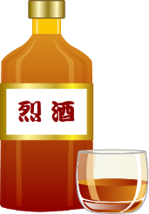  Spirits | 
Control or embargo:
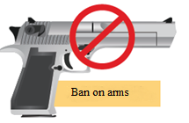 | 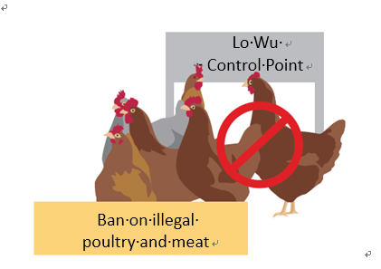

- Do you think the Hong Kong Customs and Excise Department levies duties on the above items to protect local production or for some other reasons?
The Government levies tax on them not to protect local products, but to increase
revenue for the government. This is also a means to discourage cigarette smoking
and alcohol consumption.

- The HKSAR implements control or embargo on certain goods. Do you think it violates the ideas of the free trade policy? Why?
The HKSAR Government implements control or embargo on these items to meet
public health, safety or internal security needs, or to fulfill obligations of Hong
Kong to its trading partners. (For example, the export of non endangered live
plants, animals and birds are not subject to control in Hong Kong. However, the
exporter must check and ensure in advance that he satisfies all import
requirements of the destination country/countries. Agriculture, Fisheries and
Conservation Department provides health certification services to facilitate the
export of live plants, animals and birds( https://www.customs.gov.hk/en/service-
enforcement-information/trade-facilitation/prohibited-articles/controlled-
exports/index.html).) This does not violate the free trade policy.

Let’s Do It: What industries can free trade promote?
Since trade requires the cooperation of other service industries, the boom in trade activities further increases the demand for other commercial services. The implementation of free trade policies in Hong Kong has driven the development of different service industries and created employment opportunities for Hong Kong residents. Are there any other industries that will benefit from the free trade policies?
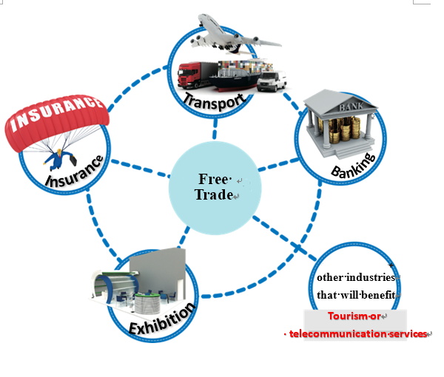
Tourism or telecommunication services
Summary
Hong Kong is a free port that enjoys prosperous development with free trade. Hong Kong implements the free trade policy and sets no trading barriers. Therefore, no duties are levied on imported or exported goods in Hong Kong, and the procedures of import and export declaration are simple. Certain goods require certification only because Hong Kong needs to fulfil obligations to its trade partners, or to satisfy the requirements for public health, safety or internal security. The open policy enables Hong Kong to be one of the largest trading economies in the world, and an international financial and commercial centre that provides services for the Asian-Pacific region and the Mainland.

Module 3.2 Overview of Our Country’s Economy and World Trade
Part 3: World Trade
(Lesson 5 and Lesson 6)
Learning and Teaching Materials

Worksheet 3: Opportunities and challenges of external trade of the Mainland and Hong Kong

Part I: Opportunities Hong Kong face in external trade
Trade has always been an important pillar of Hong Kong’s economy. Hong Kong is an independent customs territory. It participates in international trade organisations such as the WTO as a separate member and establishes economic and trade relations with other countries. According to 2021 world trade statistics, Hong Kong’s merchandise exports and imports were ranked 6th and 8th in the world respectively. The 14th Five-Year Plan supports Hong Kong in enhancing its status as an international trade centre and deepening the cooperation between the Mainland and Hong Kong and Macao in economics, trade, technology, and innovation.
Students can watch the following video after class to gain an in-depth understanding of the opportunities Hong Kong face in external trade.

 RTHK 31香港優勢(the 5th episode ) (Chinese version only)
(Length: 1 minute 40 seconds)
https://www.rthk.hk/tv/dtt31/programme/hkadvantage/episode/830683】

The Hong Kong economy has always been closely linked with the development and needs of the Mainland. The 14th Five-Year Plan* supports Hong Kong to enhance its status as an international trade centre. Hong Kong can tap into the business opportunities brought about by the twin engines of our country’s economic development in the “Belt and Road” Initiative and the GBA development. Hong Kong can also strive to establish and maintain close and stable economic and trade relations with trading partners around the world, forge free trade agreements and investment agreements, as well as expand the network of the overseas Hong Kong Economic and Trade Offices.
(*Please refer to Module 3.2 Part 1 The relationship between “The 14th Five-Year Plan” and Hong Kong’s economic development)

Source: Hong Kong Themes (October 2021)
https://www.brandhk.gov.hk/docs/default-source/factsheets/hong-kong-themes/2021-10-05/hong-kongs-role-in-the-national-14th-five-year-plan-e.pdf
Part II: Challenges Hong Kong face in external trade
Hong Kong is a small and open economy closely related to the economic development of the Mainland. With the changes in the global economic environment in recent years, Hong Kong’s foreign trade is also facing many challenges. The following is the information on Hong Kong’s trade. Try to analyse some of the challenges Hong Kong faces.

Source 1: Statistics on Hong Kong’s trade in goods and services in recent years

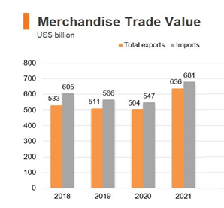 | 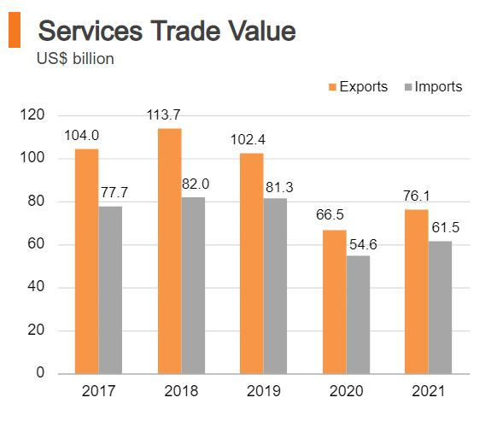
Source：
Economic and Trade Information on Hong Kong, Hong Kong Trade Development Council (27 September 2022)
https://research.hktdc.com/tc/article/MzIwNjkzNTY5

Source 2: The latest situation of Hong Kong’s external trade
The external environment worsened sharply in the second quarter of 2022. Soaring inflation in many advanced economies, which was partly caused by supply-side disruptions and elevated international commodity and energy prices amid the continued tension in Ukraine, weighed heavily on consumption demand.

In addition to the weakened external demand, disruption to cross-boundary land cargo flows between the Mainland and Hong Kong, despite the gradual improvement from the very severe situation in March, continued to constrain both exports to the Mainland and re-exports of Mainland origin to other parts of the world.

Exports of services reverted to a mild year-on-year increase of 2.3% in real terms in the second quarter, from a fall of 2.9% in the preceding quarter. Exports of travel services grew visibly as the number of inbound visitors rebounded alongside the relaxation of some travel restrictions, but remained far below the pre-pandemic level.
Source: Half-yearly Economic Report 2022, Office of the Government Economist, Financial Secretary’s Office, HKSAR Government, (August 2022)
https://www.hkeconomy.gov.hk/en/pdf/er_22q2.pdf

1. The following are some recent challenges faced by Hong Kong’s external trade. Refer to Source 2, find relevant examples to illustrate the challenges.
Challenges | Examples
Deteriorating external economic environment reduces international consumption demand | Hong Kong's external demand weakened as international commodity and energy prices remained high as a result of the war in Ukraine, weakening international demand for commodities
Mainland policy affects Hong Kong’s exports and re-export trade | Due to epidemic prevention measures, cross-border land cargo flows between the Mainland and Hong Kong has been disrupted.
The COVID-19 pandemic affects tourism | Travel restrictions reduce tourist arrivals to Hong Kong.

Source 3: Opportunities for our country’s external trade
In recent years, China has accelerated the construction of free trade zones and achieved remarkable results in building a global network of high-standard free trade zones. At present, China has signed 19 free trade agreements with 26 countries and regions. Free trade partners cover Asia, Oceania, Latin America, Europe and Africa, and trade with free trade partners accounts for about 35% of total external trade. In 2021, the import and export volume between China and its free trade partners increased by 23.6% year-on-year. This contributed to the formation of more stable industrial and supply chains between China and its free trade partners and provided important support to the stable development of world economy.
Source：人民網 (促進貿易合作 共用發展機遇) 19. May ,2022
http://cpc.people.com.cn/BIG5/n1/2022/0519/c64387-32424873.html
Source 4: Challenges faced by our country’s external trade
- The economic recovery is slowing down and showing a divergent trend. The economic prospects of various countries are showing a divergent trend. The OECD said that each economy had different advantages and disadvantages before the outbreak of COVID-19, and different measures during the epidemic, resulting in an uneven global economic recovery.
- The industrial chain and supply chain are facing challenges. The United States and Europe have accelerated the introduction of manufacturing relocation plans, accelerated the local layout of the industrial chain and supply chain. Multinational companies are adjusting the industrial chain and supply chain. The global industrial chain and supply chain are facing a new round of reconstruction, with result that the practices of regionalisation, near-shoring, localisation and short supply chain have been growing in popularity. Insufficient supply of vaccines, chip shortage for the manufacturing industry, logistics constraints on movement of goods, and soaring freight rates have put the global industrial chain and supply chain under pressure.
- Global inflation continues to run high. Rising energy prices have increased inflationary pressure in major economies and increased uncertainty for the global economic recovery.

Source Ministry of Commerce of the People’s Republic of China - 中國對外貿易形勢報告 (Fall 2021)
http://images.mofcom.gov.cn/zhs/202111/20211129152550467.pdf

2. Refer to Source 3. What strategies has China adopted to promote external trade in recent years?
China has accelerated the construction of free trade zones in recent years, and
signed 19 free trade agreements with 26 countries and regions.

Teachers’ reference：
In the report to the 20th National Congress of the Communist Party of China, it was proposed to “upgrade trade in goods, develop new mechanisms for trade in services, and promote digital trade, in order to accelerate China’s transformation into a trader of quality.” This can contribute to our country’s response to the challenges faced in international trade.

3. Refer to Source 4. Our country's external trade is being hampered by persistent global inflation. Visit the International Monetary Fund website
(https://www.imf.org/external/datamapper/PCPIPCH@WEO/OEMDC/ADVEC/WEOWORLD) to find out the latest information of global inflation.
Worksheet 4：Common trade protection policies
In order to protect the interests of some domestic industries or stakeholders, such as industries with low competitiveness in the global market, the government usually introduces some trade protection policies to support the development of those vulnerable industries. Common trade protection policies include: import tariffs, import quotas, export subsidies and embargoes.

Fill in the table below with the corresponding trade protection policies.
embargo import quota export subsidies import duty

Meaning | Trade protection policy
It is a financial subsidy for some exported goods for the purpose of supporting the competitiveness of local exports in the global market. | Export subsidy
It refers to the duties imposed on certain imported goods for raising the prices of imported goods and thus protecting similar local products. | Import duty
It refers to the setting of a limit on quantity of imports for the purpose of protecting the products produced locally. | Import quota
It refers to the banning of the import of foreign goods. A country may prohibit the import of particular goods which do not meet the standard by imposing restrictions related to health, safety and environmental protection, etc., based on the characteristics of the imported goods. Depending on the country’s needs, the policy may even be extended to all products from a certain country to interrupt all trade with that country. | Embargo

The impact of trade protection policies on different stakeholders
Trade protection policies will have varying degrees of impact on local producers, local consumers and local importers. The goal of various trade protection policies is to protect local production industries through different means and prevent the impact of the import of foreign products on local products.

a. Impact on import-competing local producers
Trade protection policies can help or even encourage local producers to face less competition. Local industries are protected and workers get more jobs.

b. Impact on local consumers
As it becomes more difficult to import goods produced in foreign places, the price of those goods may rise, resulting in higher prices for consumers and fewer choices.

c. Impact on local importers
Local importers may have to purchase goods from overseas at higher prices, increasing operating costs and weakening their competitiveness. Local consumers also buy less imported goods, which will reduce the business turnover of local importers and affect their livelihood.

Module 3.2 Overview of Our Country’s Economy and World Trade
Part 3: World Trade
(Lesson 7)
Learning and Teaching Materials

Worksheet 5: The World Trade Organization
Source 1: Introduction to the World Trade Organization and its role
The World Trade Organization (WTO) was established on 1 January 1995. The WTO currently has 164 members, accounting for over 95% of world trade. The WTO is the only international body dealing with the rules of trade among states and separate customs territories. Member governments that have joined the WTO are bound by WTO agreements to conduct their trade and trade policies according to the principles and rules. The goal is to help producers and providers of goods and services, exporters, and importers conduct their business.

In recent years, due to the rise of anti-globalisation and protectionism, the number of countries implementing trade restrictive measures is gradually increasing, resulting in a decline in the total global trade. A drop in total global trade will hurt economies, reduce jobs and hit low-income countries.

The World Trade Organization plays a mediating and restraining role in world trade, so that trade between countries can be carried out smoothly. For example, the arbitration mechanism of the World Trade Organization can help prevent conflicts between countries from becoming more serious, and most conflicts are resolved before they escalate to litigation. It can be seen that the establishment of the World Trade Organization facilitates trade between countries.

Source: World Trade Organization (WTO),Trade and Industry Department (2022)
https://www.tid.gov.hk/english/ito/wto/wto_overview.html

Source 2︰China’s accession to the WTO
From 1950 to 1977, China's total imports and exports of goods were worth only US$148.7 billion, but with China's reform and opening up and its entry into the World Trade Organization in 2001, the value of imports and exports of goods in 2004 exceeded US$1 trillion, and in 2018 it rose to a historic high of $4.6 trillion. After joining the WTO, China needs to remove various types of trade barriers, so that foreign goods and services can freely trade in China and compete directly with local Chinese goods and services. Some less competitive industries may be affected and may be eliminated by foreign enterprises, which will affect the development of domestic industries. On the other hand, China’s accession to the WTO has brought more consumption choices to domestic consumers. China's external trade has entered a new stage. In addition to improving the domestic economic level, it also drives global economic growth and enhances our country’s comprehensive national strength.
Source:. “中國的國際參與”Academies of Chinese Studies
https://ls.chiculture.org.hk/tc/national-conditions/415

- Determine whether the following items are WTO’s functions and put a "√" in the correct space.
 | True | False
Settlement of trade disputes | √
Supervision of WTO members | √
Help trading companies in various countries communicate |  | √

- Try to point out the positive impact of China’s accession to the WTO on its economy.
- China's external trade flows have increased, boosting the overall
productivity of the economy
- Expand the consumption choices of domestic citizens and improve their
living standards
- Create more employment opportunities

Worksheet 6: Challenges of our country’s external trade – China-US Trade War

Source 1: Background of China-US trade war
The economic and trade ties between China and the United States (“the US”) have grown exponentially over the past decades. China is the largest trading partner of the US, while the US is China’s second largest trading partner. However, the recent trade friction between China and the US has drawn growing attention and concern over its possible impact on the global economy, given that both countries are the world's two largest economies, accounting for about 40% of the global economy and over 22% of the world's export of goods.

The existence of a trade deficit with China in goods has over the years been the concern of the US. There have been comments that the surge in Chinese imports had led to job loss in the US, particularly in the manufacturing sector. However, there have been arguments that increased trade ties with China had indeed brought a number of economic benefits to the US economy, for instance, enabling US companies to tap into the China market with a lucrative customer base and to offer lower prices of consumer goods through low-cost production.

Source: Research Office Legislative Council Secretariat
https://www.legco.gov.hk/research-publications/english/1718in14-trade-conflict-between-china-and-the-united-states-and-its-impact-on-hong-kongs-economy-20180717-e.pdf

Source 2: The Ministry of Commerce recently released a plan to promote the high quality development of external trade during the 14th Five Year Plan period.
In order to implement the “The CPC Central Committee’s proposals for formulating the 14th Five-Year Plan (2021-2025) for National Economic and Social Development and the Long-Range Objectives Through the Year 2035” and “Outline of the 14th Five-Year Plan for the National Economic and Social Development and the Long-Range Objectives Through the Year 2035”, and to promote the high-quality development of external trade, the Ministry of Commerce has recently issued the “Plan for High-Quality Development of Foreign Trade During the 14th Five-Year Plan Period” with the approval of the State Council. The “Plan” clearly states that during the “14th Five-Year Plan” period, efforts will be made to achieve relevant goals, including:
……Further improve the trade security system: Promote the diversification of the import sources of food, energy resources, critical technologies, and components. Strengthen the risk prevention and control systems such as the responses to trade friction, export restrictions, and trade adjustment assistance.

Source: Hong Kong Trade Development Council https://research.hktdc.com/tc/article/OTIxOTE5NTM4 (7 Dec. 2021)

Use what you have learned in “Worksheet 4: Common trade protection policies” to answer the following questions.
1. Since the trade war, the United States has repeatedly imposed tariffs on Chinese goods. How do you think this will affect the export volume of Chinese goods?
The U.S. has repeatedly imposed tariffs on Chinese goods, making them more
expensive when they are exported to the U.S. The competitiveness of Chinese
goods in the U.S. market has been weakened, and the U.S. has reduced imports
of Chinese goods, with the result that the export volume of Chinese goods falls.

2. During the trade war, the United States and China have successively imposed tariffs on each other’s imported goods. What impact will this have on consumers in the Chinese Mainland?
The China-US trade war has led to higher prices for U.S. goods in China, with
the result that the Mainland consumers have fewer choices and they have to pay
more for U.S. produced goods.

Teachers’ reference：
To avoid the risk of supply chain disruption caused by trade wars, our country can adopt the strategy of building supply chain systems with partners who share similar ideologies to ours. These systems can include the “Belt and Road Supply Chain”, the “ASEAN Supply Chain” and the “Africa’s Supply Chain”.

Trade frictions may lead to unstable supply of food, consumer goods, and raw materials for production, which will bring about shocks to our country’s economy, hinder its economic development, and threaten national economic security.

References
Ministry of Commerce, People’s Republic of China
http://english.mofcom.gov.cn/

National Bureau of Statistics
http://www.stats.gov.cn/english/

People.cn
http://cpc.people.com.cn

Census and Statistics Department, HKSAR
https://www.censtatd.gov.hk/

Trade and Industry Department
https://www.tid.gov.hk/eindex.html

The Hong Kong Trade Development Council
https://research.hktdc.com/

Academy of Chinese Studies
https://chiculture.org.hk/en



